
Bapatla Engineering College :: Bapatla
(Autonomous)
Department of Information Technology

AAT-2 Questionnaire
Sub. & Code: Operating Systems & 24IT402 Date: 17-03-2026
Sections :A,B&C

*Note: AAT-2 Test is on 24.03.2026 at 07.30 AM

- a) Define deadlock. Explain about necessary conditions for deadlock. CO3 L2 5M
b) Write short note on i) Physical address & logical address CO3 L2 5M
ii) Dynamic Loading & Dynamic Linking.

2. Consider the following snapshot of a system: CO3 L3 10M

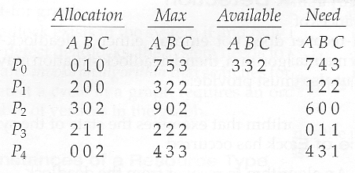
Answer the following questions using the Banker’s Algorithm:
a. Illustrate that the system is in a safe state by demonstrating an order in which the threads may complete.
b. If a request from thread P3 arrives for (4,3,1), can the request be granted immediately?
c. If a request from thread P2 arrives for (6,0,0), can the request be granted immediately?

- Define resources allocation graph. Explain deadlock prevention techniques.
CO3 L2 10 M

4. Do the Contiguous Allocation using CO3 L2 10M
- First Fit 2. Best Fit and 3.Worst Fit Algorithms
Consider Memory blocks:100KB,500KB,200KB,300KB,600KB
Discuss about internal and External fragmentation problem in Memory allocation

5. Explain the concept of paging with a neat sketch. CO3 L2 10M

6. Consider the following page reference string:
7, 0, 1, 2, 0, 3, 0, 4, 2, 3, 0, 3, 2, 1, 2, 0, 1, 7, 0, 1 CO3 L3 10M
Analyze FIFO , LRU & Optimal Page replacement algorithms and write down no.of page faults for each.

